ASSIGNMENT 2

**Question:**

Build a python code. Assume you get temperature and humidity values (generated with random function to a variable) and write a condition to continuously detect alarm in case of high temperature.

**Code:**

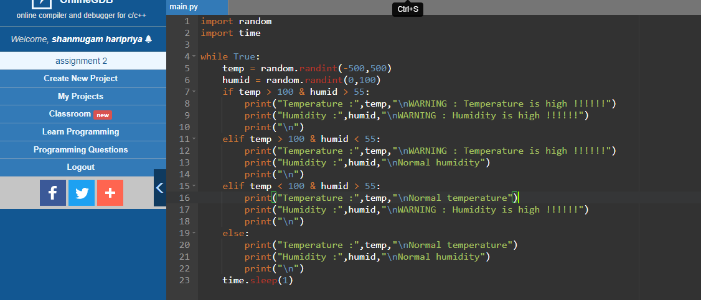

**Output:**

